**EE175AB Final Report Template**

**CAN Enabled Electric Vehicle**

**EE 175AB Final Report**

**Department of Electrical Engineering, UC Riverside**

|  |  |
| --- | --- |
| **Project Team Member(s)** | Todd Larson, Hernan Diaz, Chirag Dixit |
| **Date Submitted** | 3/19/2017 |
| **Section  Professor** | Roman Chomko |
| **Revision** | 1.2 |
| **URL of Project Wiki/Webpage** | <https://drive.google.com/drive/folders/0ByaGmgbQCjR4dmNRSmtmNW5acHM> |
| **Permanent Emails of all team members** | [hernandiaz@ymail.com](mailto:hernandiaz@ymail.com)(Hernan Diaz) , [tlarson0302@gmail.com](mailto:tlarson0302@gmail.com)(Todd Larson) ,  [cdixit2@yahoo.com](mailto:cdixit2@yahoo.com)(Chirag Dixit) |

**Summary**

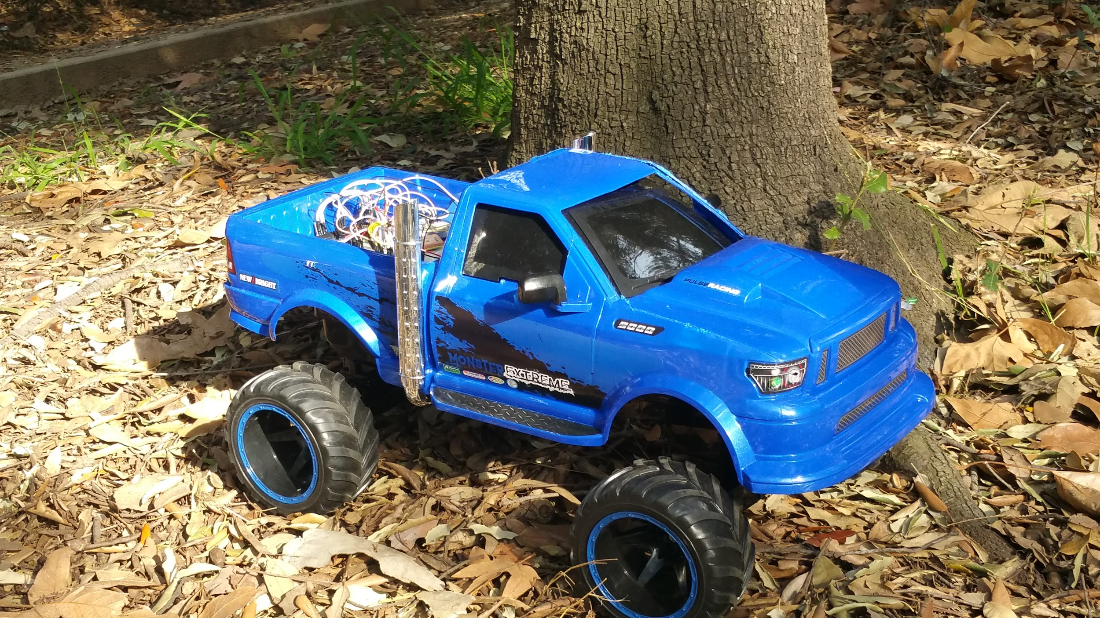

**Figure 1**

Figure 1 is the final image of the CAN Enabled Electric Vehicle.This report presents the function specification of our product CAN Enabled Electric Vehicle.

**Note:**

* **Sections marked with * are required**
* **In each section, you must clearly identify which team member is responsible for which objectives, modules or tasks.**

**Revisions**

|  |  |  |  |  |
| --- | --- | --- | --- | --- |
| **Version** | **Description of Version** | **Author(s)** | **Date Completed** | **Approval** |
| 1.1 | First Draft | Hernan Diaz, Todd Larson, Chirag Dixit | 03/10/2017 |  |
| 0.5 | First draft | Hernan Diaz, Todd Larson, Chirag Dixit | 03/10/2017 |  |
| 1.2 | Edited and fixed every section from the first draft | Hernan Diaz, Todd Larson, Chirag Dixit | 03/19/2017 |  |

**Table of Contents**

**Revisions 3**

**Table of Contents 4**

**1 * Executive Summary 6**

**2 * Introduction 7**

2.1 * Design Objectives and System Overview 7

2.2 * Backgrounds and Prior Art 7

2.3 * Development Environment and Tools 7

2.4 * Related Documents and Supporting Materials 7

2.5 * Definitions and Acronyms 7

**3 * Design Considerations 8**

*3.1* * Realistic Constraints 8

3.2 System Environment and External Interfaces 8

3.3 * Industry Standards 8

3.4 * Knowledge and Skills 8

3.5 * Budget and Cost Analysis 8

3.6 * Safety 8

3.7 Performance, Security, Quality, Reliability, Aesthetics etc. 9

3.8 * Documentation 9

3.9 Risks and Volatile Areas 9

**4 * Experiment Design and Feasibility Study 10**

4.1 * Experiment Design 10

4.2 * Experiment Results, Data Analysis and Feasibility 10

**5 * Architecture and High Level Design 11**

5.1 * System Architecture and Design 11

5.2 * Hardware Architecture 11

5.3 * Software Architecture (only required if your design includes software) 11

5.4 * Rationale and Alternatives 11

**6 Data Structures (include if used) 12**

6.1 Internal software data structure 12

6.2 Global data structure 12

6.3 Temporary data structure 12

6.4 Database descriptions 12

**7 * Low Level Design 13**

7.1 \**Module i (for i = 1 to n)* (change the italics to the name of your module) 13

*7.1.1 Processing narrative for module i (change italics to the name of your module) 13*

*7.1.2 Module i interface description (change italics to the name of your module) 13*

*7.1.3 Module i processing details (change italics to the name of your module) 13*

**8 * Technical Problem Solving 14**

8.1 * The X Problem (change X to a description of your problem, e.g., Bluetooth Interface Problem, the Line Following Problem) 14

8.2 * Solving the X Problem (change X to a description of your problem, e.g., Bluetooth Interface Problem) 14

**9 User Interface Design 15**

9.1 Application Control 15

9.2 User Interface Screens 15

**10 * Test Plan 16**

10.1 * Test Design 16

10.2 * Bug Tracking 16

10.3 * Quality Control 16

10.4 * Identification of critical components 16

10.5 * Items Not Tested by the Experiments 16

**11 * Test Report 17**

11.1 * Test 1 17

11.2 * Test i (one section for each test i = 2, …., n) 17

**12 * Conclusion and Future Work 18**

12.1 * Conclusion 18

12.2 Future Work 18

12.3 * Acknowledgement 18

**13 * References 19**

**14 * Appendices 20**

# Executive Summary

The CAN you believe it’s not a RC Car is the smaller version of an actual car. Controller Area Network (CAN) is a system of wires and protocol that connects multiple Electronic Control Units (ECU’s) to the vehicle’s computer. CAN (International Organization for Standardization protocol 11898) is an industry protocol that is is mandatory for all cars sold in the United States since 1996. CAN allows several ECU’s and sensors to communicate with each other using very few wires. It allows cars to be cheaper, smarter, and easier to diagnose. Our product allows us to explore a smaller version of the CAN bus protocol while enjoying the perks of a controllable car.

This small scaled car is controlled through a mobile app. The app can turn on the car, allowing the vehicle to move, unlock and lock doors, turn on the headlights and turn signals, as well as request the vehicle’s location through the integrated GPS module. Each feature is a toggle button on the app with its description on the side. If the car is not turned ON, the functions described above are also not ON. The app has buttons to control the car’s forward, reverse, and turn movements. Additional buttons control headlights, turn signals, and GPS data requests.

For our design we originally wanted to implement the features in a real car and control everything through our phone. To avoid any serious issues resulting from interfacing into a real car, we chose to implement a smaller, portable version by taking an older RC car and making it function with the CAN. We made it small enough to have the chassis hold our components and CAN bus, and placed the plastic body over the chassis to hold more ECU’s and the LiPo battery. This small scale model enables us to simulate a car’s communication systems in a safe laboratory environment. The app was also created and implemented to test our components as we made each ECU function.

We began by researching the CAN protocol and learning about all the needed components and communication protocols. We then proceed to test using a “CAN Bus Shield” from SparkFun. We made sure that our communication would initialize using the shield, and after confirming initialization of CAN we connected together our needed components, CAN controller (MCP2515), and CAN Transceiver (MCP2551) to initialize CAN using our own components. Next we tested each ECU separately and ensured they worked with CAN. At each stage, we had a working product, following the Agile project philosophy. Finally, we integrated all of the ECU’s, connecting them to a single CAN bus and placing them on the RC car.

In one page, present the summary of your project. Outline the motivation, overall goals, design objectives, key features, testing results, and your important achievements.

***You want to convince the readers succinctly that your project is important, useful, makes a good senior design project and you succeed in achieving your design objectives.***

***You may use several paragraphs, but no more sub-sections.***

# Introduction

*This space may be used to provide an introduction for the design and ties to other project materials.*

## * Design Objectives and System Overview

***Describe the concept and application of the design: What are you designing, technical principles, why this is a meaningful project, what are the intended applications, how is it related to subjects in electrical engineering, what are the overall goals of the project.***

The CAN Enabled Electric Vehicle models the network in a real automobile, with several features controlled through an Android app, such as controlling the direction of the vehicle, requesting the vehicle’s location through the GPS module, unlocking and locking the doors, and controlling the headlights and turn signals. The objective of our project is to implement the high-level CAN Protocol and physical layer ISO 11898 Standard Architecture on the small modeled vehicle and receive feedback from each electronic control unit via the mobile app.

This projects applies many engineering concepts and implements the industry standard communication of CAN (Extended) Protocol. In this project we use power management, computer programming, and circuit analysis.

Electrical Engineering Concepts/Subjects:

* Bluetooth Communication
* Arduino Programming
* Wiring of RC Car
* PCB Design using EAGLE
* Soldering
* Test Cases

Design goals:

* Initialize CAN communication through the physical layer ISO 11898 architecture.
* Control all modules using Bluetooth including: requesting GPS location, unlocking and locking doors, turning off/on headlights/hazards/turn signals.
* Control the vehicle using Bluetooth including forward/reverse and turning left/right.
* Receive feedback from each ECU on the mobile app.

***High-level description of the system structure, functionalities, interactions with external systems, system issues, operating environment, user environment, inputs, outputs, etc. You do not need to provide implementation details in this section.***

***You must provide a list of quantitative technical design objectives, e.g., accuracy of 95%, sensor range of 20 feet, 90% successful retrieval or recognition, mean square error < 0.1, response time < 1ms, dynamic range of 20Vp-p, bandwidth of 20MHz, transmission range>100m at 100mW, SNR>10dB, data transfer rate = 100Mbps, costing less than $500, etc.***

Quantitative Technical Design:

* Bluetooth Receiving Rate, 9600 baudrate, 30 ft. range
* DC Motor and Motor Driver
* Android Studio
* CAN Protocol, at 500 kb/s

**Responsibilities**

Hernan Diaz

* Assist in the physical implementation of the ISO 11898 Architecture
* Implement the Door Locking Module, learning to use a solenoid and step motor
* Perform initial tests of GPS Module and learn NMEA Data
* Integrate Motor Driver into RC Car

Chirag Dixit

* Create CAN message format and priority hierarchy
* Translate sensor data to send and receive over CAN bus using above format
* Implement state machine code imitating real automobile functionality (headlights, windows)
* Convert CAN message data to send over Bluetooth to Android app

Todd Larson

* Send all the data from the app to the CAN Bus
* Receive data from CAN Bus and send to the app
* Design and model the app
* Take data off the CAN Bus and use it to move the vehicle
* Implement the CAN communication

***Responsibilities: clearly state which team member is responsible for which goals/objectives***

## * Backgrounds and Prior Art

***Perform literature and Internet search to find out existing products or designs for achieving the same or similar objectives of your design. Describe your findings here. List all references in the References section (Section 14). What are the advantages and shortcomings of what you want to design compared to existing products and designs?***

There are not many small scaled implementations of CAN enabled vehicles that are used for entertainment aside for actual cars. We were able to come across the **CAN Bus Shield DEV - 13262**, which allows you to poll the ECU on your vehicle for information including vehicle speed, engine roms, and other ECUs in the vehicle. Regarding the RC Car, there are plenty of models and different prices depending on the material of each vehicle.

**Silverlit Ferrari Enzo - Cost of R/C Car: $67.57, Amazon**

The Silverlit Interactive Bluetooth RC car is controlled with the iPod Touch/iPhone. It accelerates forwards when the mobile phone is tilted and tilts left or right when the phone is tilted as well. The app replicates the dashboard design allowing you to get a feel for the variable speeds. Headlights, tail lights, and signal lights are also controlled via the app

**Our Product’s Disadvantages:**

The disadvantages of our product is that our RC Car is a lot bigger and heavier. It also requires 11.1V in order to maintain all ECUs powered which would require constant care when charging the LiPo battery which can cause a hazard if not taken care of.

**Our Product’s Advantages:**

Our product includes a GPS module that sends over the location of the vehicle via the app. It also implements the industry standard CAN Communication which is built into all vehicles since the 1990’s. We are also able to implement the door locking mechanism allowing us to open and close the door on the vehicle.

http://modelrail.otenko.com/arduino/arduino-controller-area-network-can

## * Development Environment and Tools

***Describe the design environment, hardware and software tools, and testing equipment required to complete this project. Example, your hardware development environment is Raspberry pi with Linux, you used Android Studio for your app development, etc.***

The software side of the project we need Arduino IDE to program the Arduino Unos and Android Studio to develop our app. We also need the software to debug the software for each component.

The hardware tools we need are power supplies, oscilloscope, and multimeter. Power supplies are needed to test the circuits we create and the modules we use. We need the oscilloscope to verify the data we send over the CAN bus is correct. The multimeter is needed to measure the current going through the system and measure the voltages to test correct output values.

## * Related Documents and Supporting Materials

***References to any industry standards involved in your project should be listed here.***

Some of the related documents in regard to learning about what CAN is and how it functions.

* Introduction to the Controller Area Network (CAN) - KVASER
* Controller Area Network (CAN) Prototyping with Arduino By Wilfried Voss
* CAN Protocol Tutorial Kvaser - ISO 11898-1 and ISO 11898-2
* Stand-Alone CAN Controller with SPI Interface - MCP2515 Microchip
* High-Speed CAN Transceiver - MCP2551 Microchip

***(Optional) – Note any other references or related materials. For instance, if this design required interfacing with X10 hardware devices, then you would want a reference to the X10 specification. If you use the .NET development environment or need to interface with MS Internet Explorer, the related documents should be referenced here.***

## * Definitions and Acronyms

***List any project definitions and acronyms introduced to the project by this design.***

* CAN – Control Area Network
* CANH - CAN High
* CANL - CAN Low
* ECU – Electrical Controller Unit
* PCB – Printed Circuit Board
* SPI – Serial Peripheral Interface
* USART – Universal Synchronous/Asynchronous Receiver/Transceiver
* RC – Remote Controlled
* GPS – Global Positioning System
* LiPo – Lithium Polymer Battery
* ID – CAN message identifier
* OBD – On-Board Diagnostics

# * Design Considerations

***This section describes issues that need to be addressed or resolved prior to or while completing the design as well as issues that may influence the design process.***

## Realistic Constraints

Some realistic constraints are the GPS unit, bluetooth range, overcharging, and space. The GPS unit cannot work inside of buildings. The GPS has to be outside and the sky has to mostly clear. Also the GPS unit is accurate up to three meters. We are able to put five of the ECUs on the RC car. However, there is limited amount of physical space on the RC car. Five ECU’s seem to be the most we can store on the RC car. Also, the Bluetooth module has a limited range of around ten meters. Once the RC car is out of range, we do not have any control over the system. A fully charged LiPo battery cell has a voltage around 4.1V. We use a three cell LiPo battery, its voltage at max charge is 12.3V. The motor driver’s max input voltage is 12V. If we fully charge our LiPo, it will overcharge the motor driver and fry the motor driver.

## System Environment and External Interfaces

***Describe the system, hardware and software that your product must operate in and interact with, any communication protocols and APIs the system must comply to, etc.***

## * Industry Standards

***Describe the industry standards involved with the hardware and software in your design. This may include hardware, software and protocols, such as RS232, I2C, USB, PCI, IEEE802.11, Bluetooth, Zigbee, RFID, UAL, safety standards, etc. Also discuss de facto standards such as operating system APIs, device drivers, programming language/environments, popular interfaces such as SPI, etc. used in your project.***

***You must reference the standards documents and describe how you design will comply with the standards.***

***You must describe how the standard requirements affected your design and include examples of aspects of the standards that you encountered in your design projects, e.g., voltage levels, packet size, baud rate, data rate, carrier frequency, etc.***

Standards:

IEEE 802.15.1, Bluetooth, wireless connectivity with fixed, portable and moving devices within or entering personal operating space. We use the IEEE 802.15.1 standard to connect our application to the CAN enabled electric vehicle. We set the minimum Baud rate for Bluetooth to be 9600 and our packet size is one byte of data.

IEEE 1394,USB, used for computer peripherals. We use it to program the Arduino Unos and an android phone for the android application.

GPS, a navigation satellite system that provides geolocation and time information. We use it to find our GPS location and output the data on the Android application.

De facto:

C/C++ programming a common programming language. We use this language to program the Arduinos and the Android Application.

SPI is a synchronous serial communication interface and its use is for short communication between systems. We use this to communicate between the MCP2515 and Arduino Uno.

USART is a serial interface that is programmed to communicate asynchronous or synchronous devices. We use it to communicate between the Arduino and Bluetooth module, and the Arduino and the GPS module.

## Knowledge and Skills

**Todd Larson**

* CS122A(Embedded Systems)
* EE100A(Electronic Circuits)
* CS10-14 (C++/C programming)
* Arduino

Skills learned:

* CAN Communication
* Android Studio
* Bluetooth Communication

**Hernan Diaz**

* CS 120B(Embedded Systems)
* EE100A & EE100B (Electronic Circuits)
* CS10-14 (C++/C programming)

Skills learned:

* CAN Communication
* Bluetooth Communication
* Arduino IDE
* GPS Module with National Marine Electronics Association Data
* Knowledge on Relays and Stepper Motors

**Chirag Dixit**

* CS122A(Embedded Systems)
* EE100A(Electronic Circuits)
* CS10-14 (C++/C programming)

Skills learned:

* CAN Communication
* Arduino IDE
* Bluetooth Communication

## Budget and Cost Analysis

|  |  |  |  |
| --- | --- | --- | --- |
| Item Description | Quantity | Cost per Item | Total |
| RC Car | 1 | $40 | $40 |
| MCP2515-I/P-ND IC CAN Controller W/SPI 18 DIP | 5 | $1.87 | $9.35 |
| MCP2551-I/P-ND IC Transceiver CAN HI-SPD 8-DIP | 5 | $1.05 | $5.25 |
| Crystal 16.000MHz 20pF T/H | 5 | $0.39 | $1.55 |
| 2200mAh 3S 20C Lipo Pack | 1 | $6.99 | $6.99 |
| DROK L298N Motor Drive Controller Board | 1 | $18.14 | $18.14 |
| Arduino Uno | 5 | $10 | $50 |
| Sparkfun CAN Bus Shield | 2 | $25 | $50 |
| Adafruit Neo-6M GPS | 1 | $40 | $40 |
| Total | --- | --- | $221.28 |

Table 3.1

We set out a budget of $300, $100 per person, and table 3.1 shows our total cost is $221.28. We come under budget of our project. With a total cost of $221.28, we each spend $73.76.

## Safety

The biggest safety concern with our project is the Lipo battery. A mishandled Lipo battery can become a serious safety concern. A mishandled Lipo can explode or spontaneously combust. Our top priority is the treatment of the Lipo battery. We made sure the Lipo was secured in the bed of our RC car by laying down bubble wrap where the Lipo is placed. Then we taped the Lipo to the bed of the RC car and made it easy to remove if something were to happen.

## Performance, Security, Quality, Reliability, Aesthetics etc.

***Describe the considerations and processes to ensure meeting performance, security, quality control, reliability, aesthetics etc. requirements.***

We ensured performance of the LiPo battery when ECU’s were connected by testing the current and voltage. We ensured that the 11.1V battery was properly stepped down to 5V for the Arduino ECU’s by testing the voltage delivered as we connected each ECU module to the CAN bus.

Our only security concerns were regarding the unsecured Bluetooth communication between Android app and Arduino. We chose not to secure this communication due to the limited capability of our project to do damage in addition to the small 10 meter range of our Bluetooth module.

One significant constraint was physical space on our RC car. We were only able to place 5 Arduino ECU’s in the chassis and bed of our toy truck. This number was only possible because we reduced the CAN transceiver and CAN communicator to fit on a small custom PCB (Printed Circuit Board).

## * Documentation

***Describe the processes for generating and maintaining technical and user documentation for the project, including design notes, engineering change notices, version update and version control procedures.***

We use Google Drive for maintaining documentation. Google Drive offers collaborative web tools such as Google Docs. All applications in Google Drive have version control, which we utilize for our documentation, notes, resource tracking, and code. Additionally, we use lab notebooks and sketchbooks for most of our design notes, drawings, and schematics.

## Risks and Volatile Areas

***(Optional) - Describe any notably volatile or risky areas of the system and any special strategies taken to mitigate risks or prepare for changes. These are risks specific for the design—not project management type stuff. For instance if there is an algorithm that is especially difficult that you must implement.***

# Experiment Design and Feasibility Study

***Include this section if you need to conduct experiments to evaluate the feasibility of your project ideas, alternatives, trade-offs and realistic engineering constraints, and to answer key design questions, such as what parts to use, how to collect data, whether accuracy of sensor is sufficient for the design objective, whether battery provides enough power, what hardware or software interface methods to use to connect the different modules, etc.***

***Examples:***

***If you want to use ultrasound sensor to detect obstacles in real time, you need to design experiments to verify whether this is feasible, analyze the data to determine the accuracy, sampling speed (how quickly can you get a measurement to meet real time requirement), sensing angle etc.***

***If you want to use hall effect sensor to measure speed and distance traveled, do experiments and data analysis to determine the accuracy, sampling speed (how quickly can you get a measurement to meet real time requirement) etc.***

***If you want to use an inverter to convert DC to AC, do experiments and data analysis to verify what input voltage and current range is required to produce an acceptable AC supply.***

***If you want to use an amplifier to amplify EEG signal, do experiments and data analysis to determine what is the gain and filtering required.***

For our project we needed a way to provide enough power to all of our components for a good amount of time, while taking into consideration the weight and size of our power supply. When we tested our DC Motors we noticed that a good amount of current and voltage was needed to make them run . The motors run at 9 V, with 1.5 A spike when you first choose a direction, and then a constant 0. 35 A after the speed and direction has been chosen. We bought an 11.1 V LiPo battery with 2200 mAh in order to provide enough to power the DC motors and the rest of our components.

To recreate a locking and unlocking mechanism we had decided to use a solenoid. We were able to get a hold of a solenoid and test it out, working at around 6.2 V drawing 1.1A in order to function. After testing with our LiPo in order to provide that much power we quickly realized the solenoid was drawing too much power even after using the correct circuit to make it function. Although we wanted to use it for a short amount time, we wanted to avoid running in troubles of overheating, especially if the car was moving. We proceeded to use a stepper motor and attached a lever at the end and created a latch as our locking and unlocking mechanism. It was a lot safer to use and just as efficient.

Our GPS initially gave us trouble, but once we figured out the correct baudrate, it began sending data. We quickly realized that in order for it to obtain a signal, we had to be outside, where it would capture a signal within 2 minutes on a clear day. We tested its ability to obtain a signal in a few different situations as summarized by the following table. We made a tradeoff to use an entire ECU for the GPS even though it only worked in limited conditions because we believed that sending complex GPS sensor data over the CAN bus would better enhance our knowledge of the CAN protocol.

|  |  |
| --- | --- |
| Environment | Signal Captured? |
| Indoors | No |
| Outdoors - Clear daytime | Yes |
| Outdoors - Rain + clouds | No |
| Outdoors - Clear nighttime | No |

## * Experiment Design

***Describe the objective, setup, procedure and expected results of each experiment.***

***State clearly who is responsible for which task***

***Responsibilities:***

***Hernan Diaz:***

CAN Bus Shield Testing

|  |  |
| --- | --- |
| Setup | Attach the Shield on top of the Arduinos and connect to Arduino IDE. |
| Procedure | Upload the given code from Sparkfun, modify code to send correct information, and upload the code. |
| Expected Results | On the Serial Monitor we should get a message saying CAN initialization was achieved. |

***Chirag Dixit:***

GPS Obtain Signal Test

|  |  |
| --- | --- |
| Setup | Connect GPS to Arduino. Use TinyGPS library and examples for code. |
| Procedure | Connect Arduino to computer, observe serial monitor for signal obtained data (latitude/longitude). |
| Expected Results | Serial monitor displays NULL indoors. Serial monitor displays latitude/longitude data outdoors. |

GPS Accurate Signal Test

|  |  |
| --- | --- |
| Setup | Connect GPS to Arduino. Use TinyGPS library and examples for code. |
| Procedure | Connect Arduino to computer, observe serial monitor for signal obtained data (latitude/longitude). |
| Expected Results | Serial monitor displays latitude/longitude data outdoors. Coordinates are accurate to 2 decimal places of Google Maps latitude/longitude coordinates. |

***Todd Larson:***

Bluetooth Connectivity Send

|  |  |
| --- | --- |
| Setup | Program the main hub Arduino to receive and the app to send messages via Bluetooth |
| Procedure | First output if the app has connected to the Bluetooth module via a toast. Then send data to the Arduino via buttons on the app. Then look at the Arduino’s serial monitor to see if the correct data is displayed. |
| Expected Results | The Arduino Uno displays the correct data when it is sent from the app. |

## * Experiment Results, Data Analysis and Feasibility

***Carry out the experiments designed above and present experimental data, quantitative analysis of the data, and the conclusion to show the feasibility of your project idea, how the experiments help you decide whether your technical design objectives can be achieved, and how they help you select the best solution to be further developed in the design project.***

***State clearly who is responsible for which task***

**Hernan Diaz:**

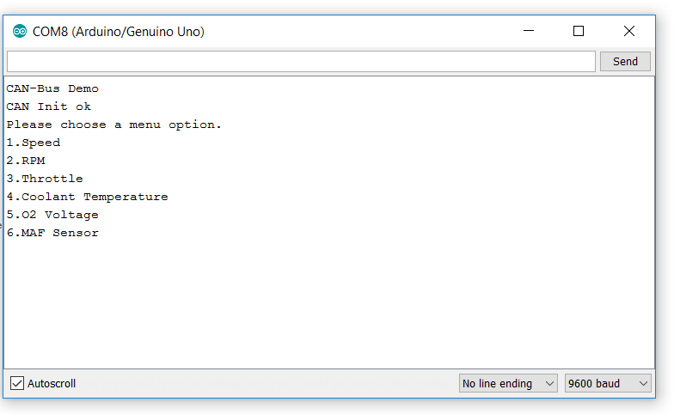

Using the SparkFun CAN Bus Library provided with the shield, I was able to set up two shields, one for receiving and one for sending messages. I was able to make both ECU modules initialize and then implemented the code in order to make both ECUs capable of reading and receiving messages. By making the CAN Bus Shield initialize we proceeded to make our own PCB designs that contained the necessary components in the shield and make them function to our use, making our component smaller, and cheaper, and just as effective as the shield.

**Chirag Dixit:**GPS Obtain Signal Test Results  
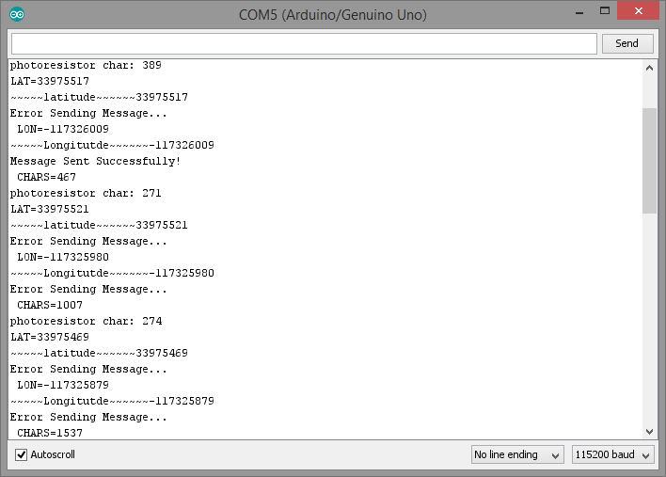

Fig. 4.2.1 GPS module (not connected to CAN bus) is sending data to Arduino, which displays latitude and longitude on the serial monitor

GPS Accurate Signal Test Results  
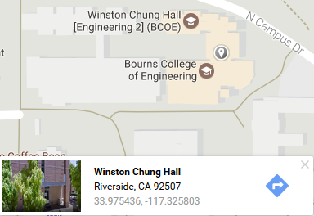

Fig. 4.2.2 Latitude and longitude of Winston Chung Hall according to Google Maps. Comparison of coordinates to coordinates in Figure 4.2.1 indicates that the GPS module sends accurate data.

The GPS testing helped us accomplish two things: the ability to obtain sensor data and the ability to translate that data into a CAN message format. These tests showed us that we could connect any sensor (GPS being the most complex) to our Arduinos, translate the data into CAN message format, send sensor data over the CAN bus, and have periodic updates of sensor data on the CAN bus for all ECU’s to read.

The headlights ECU tests proved that we could send commands from our Android app to control elements on our car. We successfully demonstrated that we could send and receive via multiple layers of communication, namely Bluetooth and CAN.

**Todd Larson:**

**(Show screenshots of data being sent between phone and Arduino)**

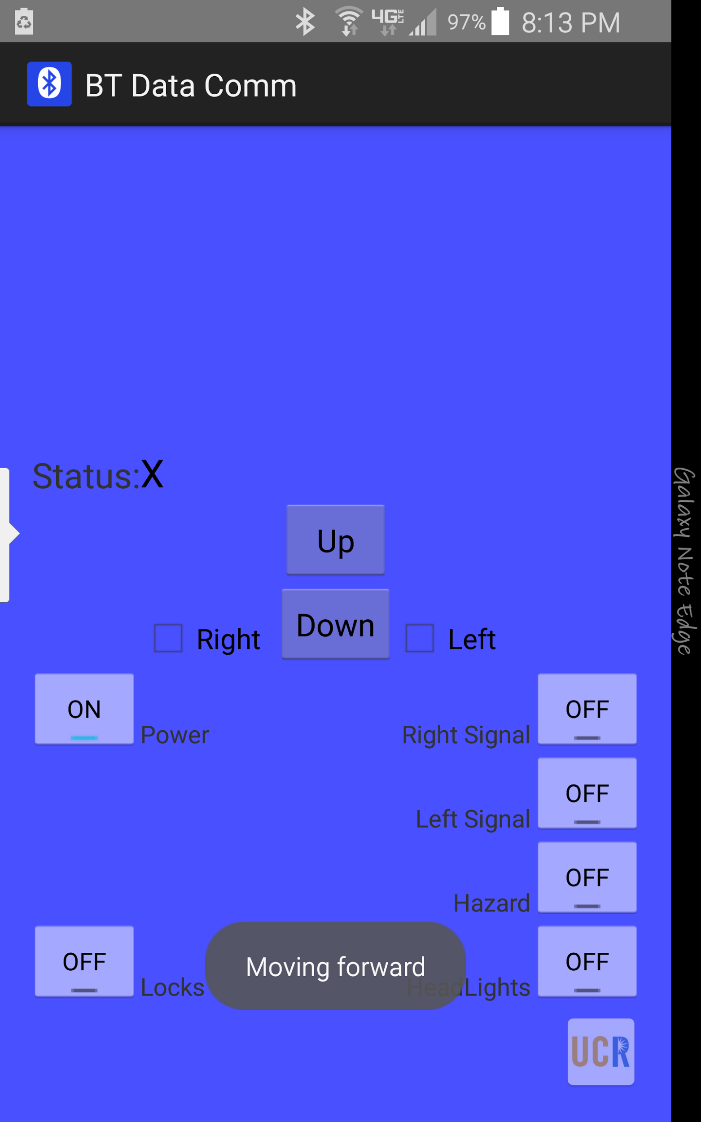

Figure 4.3

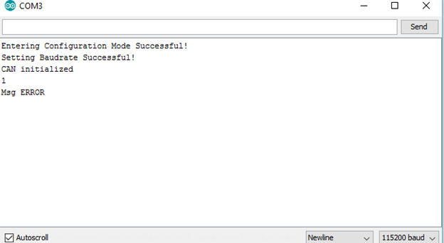

Figure 4.4

The Bluetooth test accomplishes different types of data sending over to the Main Hub ECU to be sent through the CAN BUs. When the up button is pressed on the app the toast appears that the data is sent. Then the Arduino’s serial monitor displays the data that is sent by the Android app. Figure 4.4 shows the Arduino’s serial monitor receiving the data and Figure 4.3 shows the app outputting it sent the data.

# * Architecture and High Level Design

***The architecture provides the top level design view of a system and provides a basis for more detailed design work. These are the top level components of the system you are building and their relationships.***

## * System Architecture and Design

***This section provides a high level overview of the structural and functional decomposition of the system. Focus on how and why the system is decomposed in a particular way rather than on details of the particular components.***

***Include information on the major responsibilities and roles the system (or portions thereof) must play. A block diagram representation of the architecture must be included, which should show the hierarchical structure of the modules; interaction and interface among modules and with databases, external software, system, and networks***

***Provide a description and block diagrams of a system element or set of elements at a conceptual or functional level that describes a clearly defined view or model of the entire system or a subset of the system. Each component represents a similar grouping of functionality.***

***State clearly who is responsible for which module/task***

**Hernan Diaz:**

* CAN Bus Shield - CAN Initializing
* GPS Module- Proper Functioning
* Door Locking Mechanism
* L298 Dual H- Bridge Motor Driver set up with Vehicle
* Relay - On/Off switch

**Chirag Dixit**

* CAN message priority and identification format
* GPS: Translation to/from CAN and to Bluetooth
* CANHub: CAN to Bluetooth translation
* Headlights ECU: Coding for headlights, turn signals, hazard, and brake lights. Assembly of components and wiring.
* Code management

**Todd Larson:**

* App design
* Bluetooth communication
* CAN communication from main hub ECU to rest of ECUs
* Main hub ECU
* Motor driver ECU

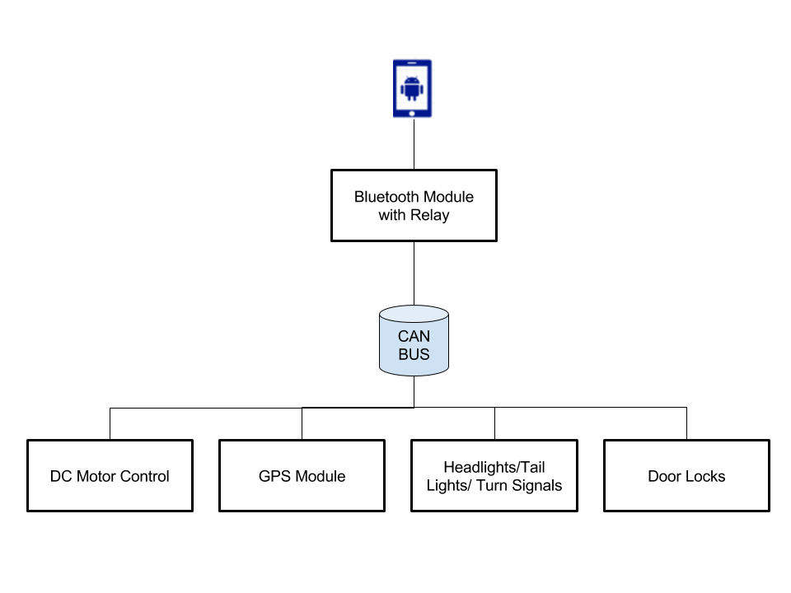

**Figure 5.1**

Figure 5.1 is the overall diagram of our ECU’s connected to the CAN bus line and operated the mobile app. The main ECU consists of the Bluetooth module that receives and sends all the messages unto the bus line and from there the ECU’s take over.

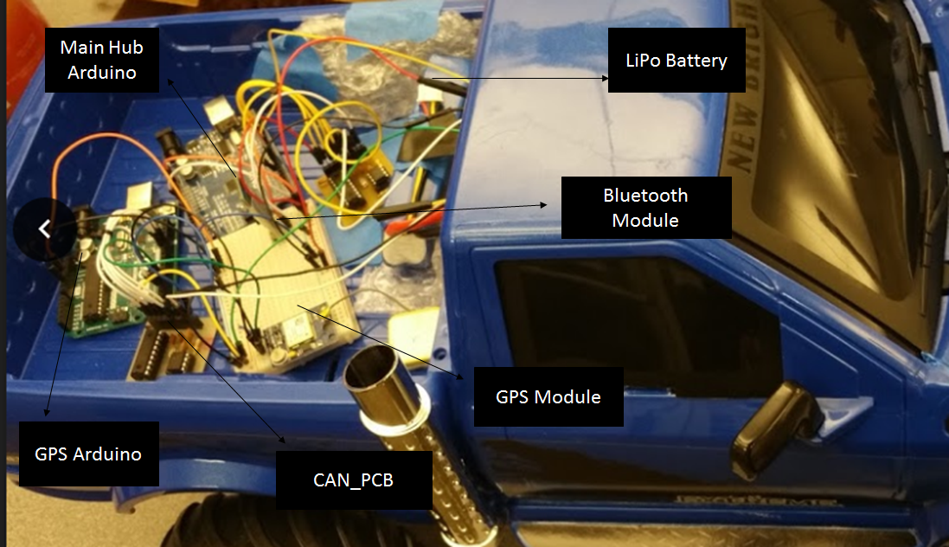

**Figure 5.2**

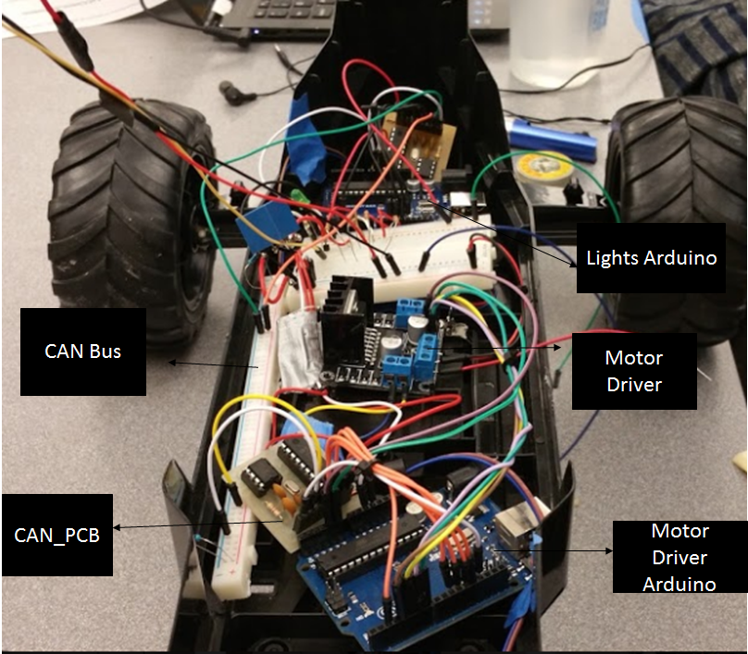

**Figure 5.3**

Figure 5.1 is the high level schematic of our project. It consist of our mobile app on the Android phone, that communicates via bluetooth to the Main ECU hub which then sends the message to the CAN bus line and the ECU’s take over responding to their corresponding identifiers on the bus.

Figure 5.2 displays the outside of our vehicle, it holds the LiPo battery that powers all our microcontrollers and ECU’s. On the outside we also have our GPS and Bluetooth modules that work in area that is not being covered and allows for communication. Figure 5.3 displays the inside of vehicle where our CAN bus line is located, as well as our motor driver. A breadboard is located on the inside which is used for the power strip to power all our ECUs and to place our pins on here as our centerpoint.

## * Hardware Architecture

***Show hardware block diagram showing hardware functional blocks and how they interface.***

***State clearly who is responsible for which module/task***

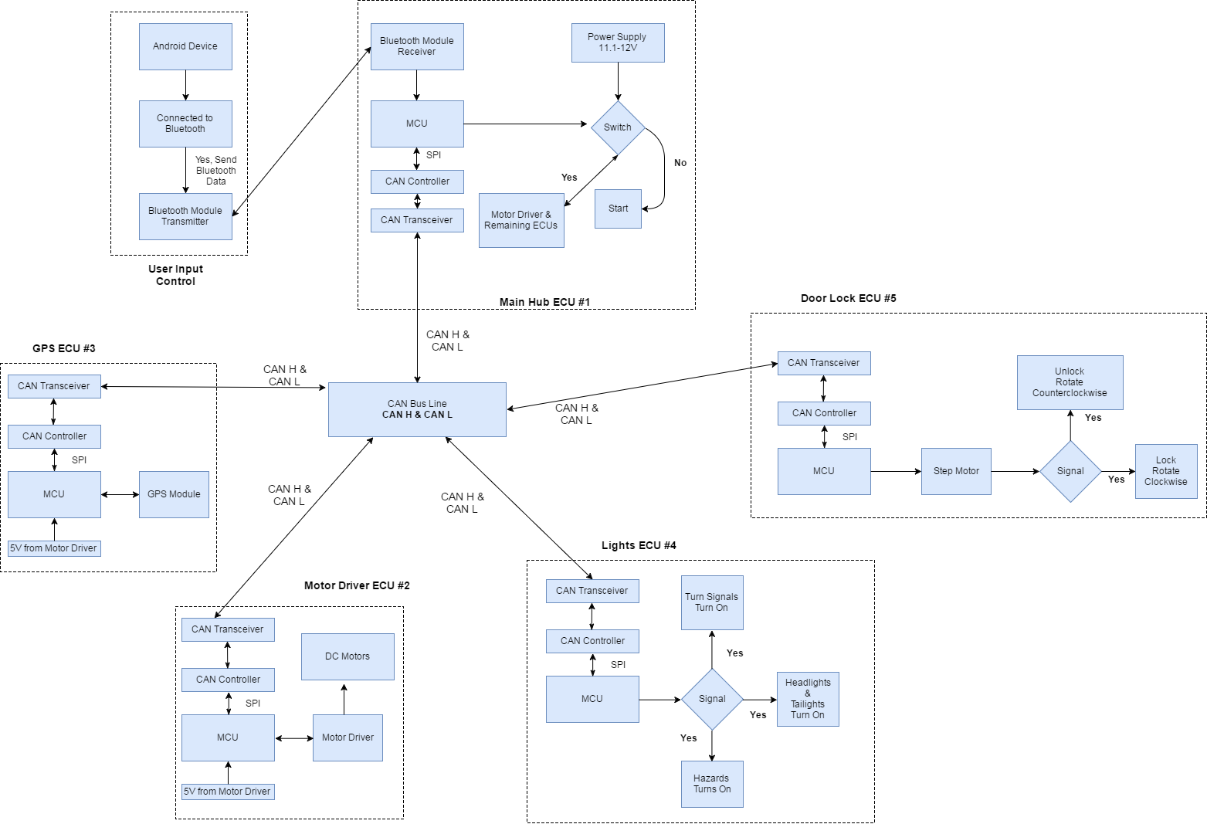

**Figure 5.4**

Figure 5.4 shows our System Block Diagram where all our ECU’s are connected via the CAN Bus line and controlled by the mobile phone. Each ECU consist of a CAN Controller and Transceiver that handles all the communication and delivers the message to its corresponding module. After going through the CAN Controller and Transceiver the messages are sent to its corresponding unit such as the GPS or Motor Driver. From there the unit does it’s job and communicates back again via the bus if needed to, in this case it would be correspond to the GPS module and Door locking unit.

## * Software Architecture (only required if your design includes software)

***Show software block diagram***

***State clearly who is responsible for which module/task***

**Software Libraries**SoftwareSerial (https://www.arduino.cc/en/Reference/SoftwareSerial)  
TinyGPS (https://github.com/mikalhart/TinyGPS)  
MCP_CAN (https://github.com/coryjfowler/MCP_CAN_lib)

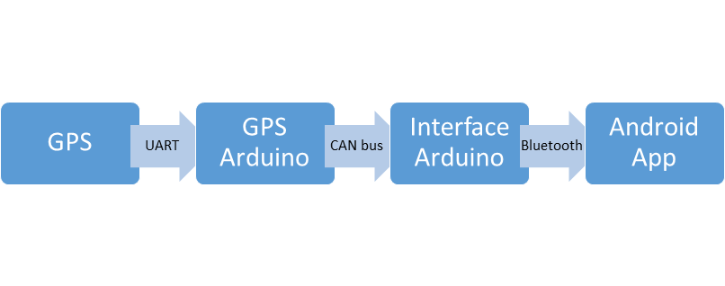

**Figure 5.3.1**

Flow diagram of GPS latitude/longitude data from GPS module to display on Android app. Three layers of communication are used between four devices. Each layer of communication requires its own unique translation.

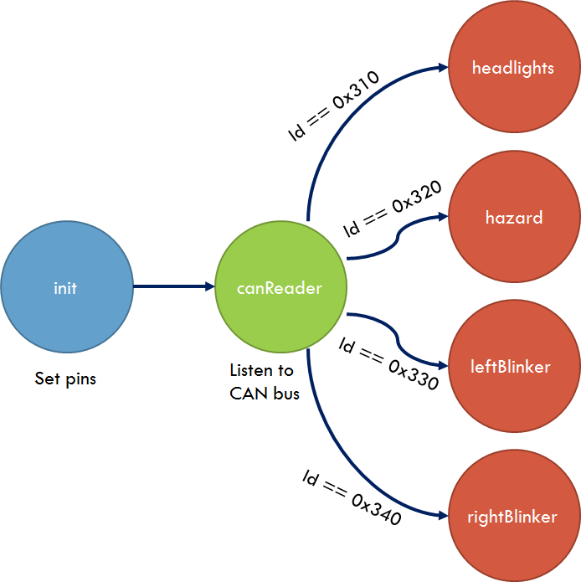

**Figure 5.3.2**

LightsECU finite state machine diagram overview. The canReader state machine is a constant loop that enables or disables other state machines based on identifier bits in messages received on the CAN bus.

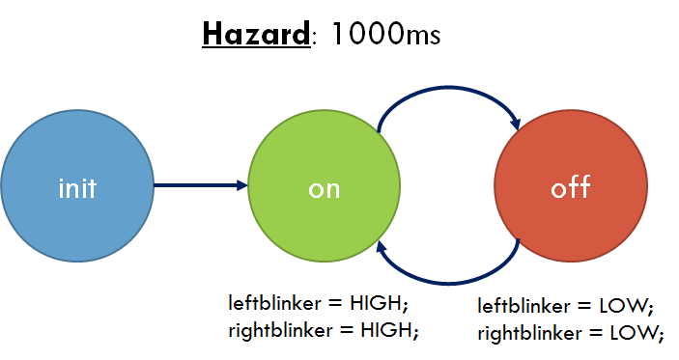

**Figure 5.3.3**

Finite State Machine for controlling Hazard lights. This FSM simply loops unconditionally between 2 states every 1 second, turning the blinker LED’s ON or OFF.

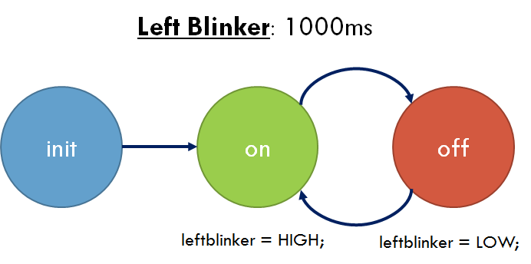

**Figure 5.3.4**

Finite State Machine diagram for Left Blinker. This FSM simply loops unconditionally between 2 states every 1 second, turning the left blinker LED ON or OFF. The Right Blinker state machine is identical to this Left Blinker state machine, with the exception that the former controls the right blinker LED.

## * Rationale and Alternatives

***This section discusses why you are using the architecture or approach you have decided upon. A discussion of other architectures or approaches considered should be presented here.***

Our design goal was to recreate and model what real car does through the CAN enabled vehicle. In order to avoid spending too much on buying CAN Bus shields, we created a PCB that would hold the necessary components,the CAN Controller (MCP2515) and CAN Transceiver (MCP2551). This avoided spending too much and we would reduce the size and weight of our ECUs.

# At first we wanted to use multiple AA batteries to power our vehicle but came to the conclusion that a LiPo battery would do a better job. Not only is it slightly lighter and smaller, it also has enough power to make our components function properly. It allows enough current and voltage to be drawn from our DC motors.

We also had stated we would use a solenoid in order to create our door locking unit but after testing out the solenoid we quickly came to realize the solenoid was drawing 1.1A at 6.2 V in order to properly function. This would not only affect the duration of Li-Po battery, if the solenoid would to overheat due to overusing it, it could cause damage to the surrounding components. We avoided this by substituting the solenoid with a stepper motor that would act as a latch to the door. It was a safer option, it drew less current and power, yet we sacrificed time and room in our vehicle.

# 6 Data Structures (include if used)

A description of all data structures including internal, global, and temporary data structures. State clearly who is responsible for which module/task

## Internal software data structure

Data structures that are passed among components the software are described.

Headlights ECU (Chirag)  
Finite State Machine (FSM): We use FSM’s to control the flow of our hazard, left blinker, and right blinker processes. FSM’s provide fixed periods for each state to execute. We use this ability to control how fast our lights blink by transitioning from ON state to OFF state after a 1000ms period. We also use an FSM for reading data from the CAN bus. This FSM reads data from the CAN bus every 50ms. It enables or disables other FSM’s based on CAN messages transmitted from other ECU’s.

## Global data structure

Data structured that are available to major portions of the architecture are described.

CANHub (Todd and Chirag)

byte array: Holds the data to be transmitted over CAN. We must translate all data into a byte array format to send it using the MCP CAN Arduino library. The GPS ECU (Chirag and Hernan) converts long data into a byte array format to send over CAN.

## Temporary data structure

Files created for interim use are described.

GPS ECU (Chirag and Hernan)  
TinyGPS GPS: Class imported from the TinyGPS Arduino library. Contains a function encode(char x) that can translate serial data from the GPS module into readable format. Once the data is in the TinyGPS class, we can obtain a long or float format for the latitude/longitude coordinates. We translate the long data to our CAN byte array described in “Global data structure”.

## Database descriptions

Database(s) created as part of the application is(are) described.

Not Applicable

# * Low Level Design

***This section provides low-level design descriptions that directly support construction of modules. Normally this section may be split into separate documents for different areas of the design. For each component we now need to break it down into its fundamental units or modules. Each module or block may be hardware or software or a subsystem implemented using hardware and software. Make sure to provide a well-commented schematic of all modules and/or system blocks described in the system block diagram (SBD).***

*Must include hardware circuit schematics and program flowchart for each module.*

Example of circuit schematics: http://www.arduino.cc/en/uploads/Main/arduino-uno-schematic.pdf

Example of flowcharts of your programs: http://www.mdpi.com/electronics/electronics-03-00636/article_deploy/html/images/electronics-03-00636-g011-1024.png

## *CAN_PCB

***Provide or reference a detailed description, schematic and/or diagrams of this module. Repeat this section for each module i.***

***State clearly who is responsible for which module/task***

### Processing narrative for *CAN_PCB*

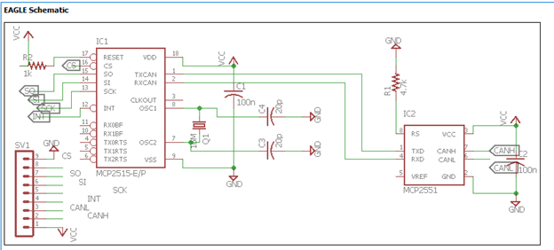

Figure 7.1

The CAN_PCB serves to send and receive signals through the CAN Bus. This is the main module that connects to our Arduino to the CAN Bus. Figure 7.1 shows the schematic for the CAN_PCB.

### *CAN_PCB* interface description

A detailed description of the input and output interfaces of the module with other modules in the system, with other software or systems or module is presented.

The CAN_PCB communicates to the Arduino Uno using SPI. It has 1 power pin, 1 ground pin, 2 I/O pins, 2 output pins, and 3 input pins. Pins 2 through 6 are reserved for the SPI communication and interrupt to the Arduino. Pins 7 and 8 are for CANH and CANL. Pin 1 is the power, which it takes 5V, and pin 9 is for the ground. We used software to send and receive data from the CAN_PCB to the Arduino.

### *CAN_PCB* processing details

A detailed description for each module is presented, including hardware, algorithm, local data structures, design constraints, limitations, performance issues, etc.

Module Specifications:

* Communication: SPI and CAN communication
* Baudrates to the CAN bus: 5k, 10k, 20k, 50k 100k, 125k, 250k, 500k, and 1000k
* Power supply: 5V

## *Arduino Uno

### 6.2.1 Processing narrative for *Arduino Uno*

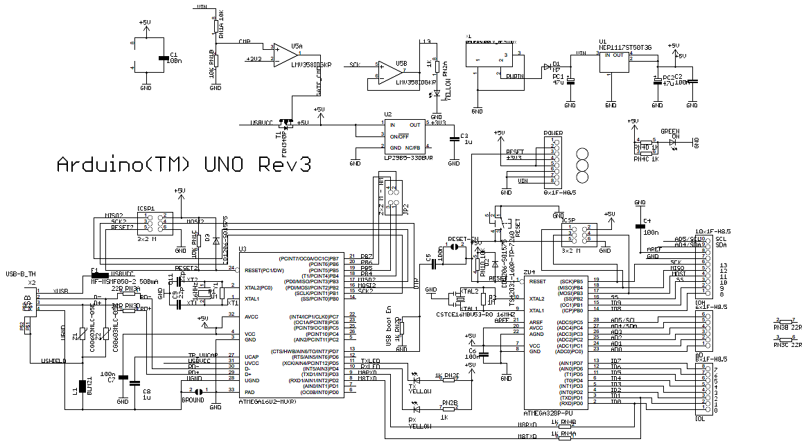

Figure 7.2

The Arduino Uno is used to be the MCU for each ECU on the CAN bus. Each Arduino Uno is programmed to filter data on the CAN bus and then to act accordingly to what the sent data tells the Arduino to do. It uses SPI to communicate between itself and the CAN_PCB. Above is Figure 7.2, the schematic for the Arduino Uno.

### 6.2.2 *Arduino Uno* interface description

The Arduino Uno communicates through SPI on pins 10 through 13 to the CAN_PCB. As well pin 2 is reserved for the interrupt of the CAN_PCB. The Arduino Uno requires 5 V to run and it has others pins that we used to design each ECU.

### *6.2.3 Arduino Uno* processing details

Module Specifications:

* Communication: SPI and USART
* Baudrates: 300, 600, 1200, 2400, 4800, 9600, 14400, 19200, 28800, 38400, 57600, or 115200
* Power supply: 5V

## GPS

### Processing narrative for *GPS*

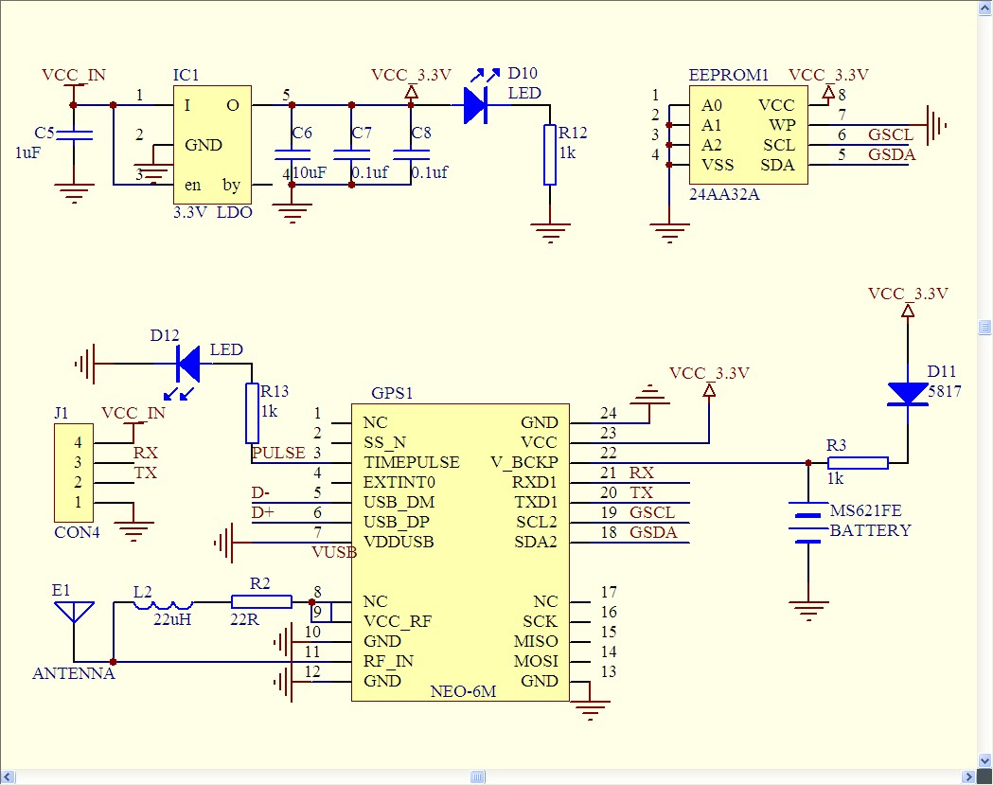

Figure 6.3

Figure 6.3 is the schematic for the Adafruit Neo 6m GPS unit. The GPS unit uses USART to communicate to the Arduino. It finds the GPS coordinates and then transmits them to the Arduino. It still transmits data even if it has not found a signal.

### 6.3.2 GPSinterface description

The GPS has four pins, one for power, one for ground, one for RX, and one for TX. Through the RX and TX pins of the GPS, it sends the Longitude and Latitude of its location.

### *6.3.3 GPS* processing details

Module Specifications:

* SPI communication
* 9600 baudrate
* 111 mW @ 3.0V (continuous)
* 33 mW @ 3.0V Power Save Mode (1 Hz)
* NMEA input/output, ASCII, 0183, 2.3 (compatible to 3.0)

## Motor Driver

### 6.4.1 Processing narrative for *Motor Driver*

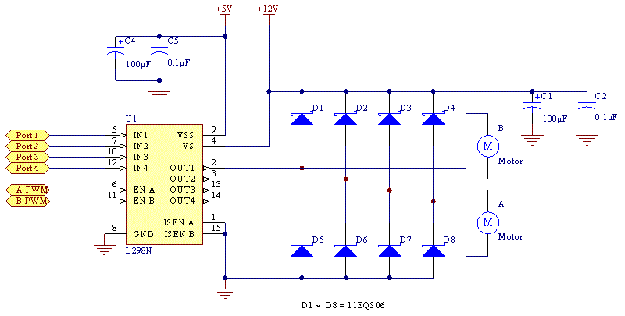

Figure 7.4

We use the DROK L298N Motor Drive Controller Board. The Motor Driver serves as way to control the motors on the vehicle. Figure 7.4 shows the schematic of the Motor Driver. One of the Arduino Uno’s connect to the motor driver to control the front and rear motors. The front motors turn the vehicle and the rear motors control the power. The Motor driver also serves as a power source to power some of the Arduinos.

### 6.4.2 Motor Driverinterface description

The Motor Driver has one power pin for 12V, one pin for GND, and one pin for 5V. It also has two inputs for the PWM of each motor and has four pins to control the direction of each motor. There is four output pins, two that control one motor and two that control another motor.

### *6.4.3 Motor Driver* processing details

* Chip: L298N
* Logic voltage: 5V
* Logic current: 0mA-36mA
* Drive voltage: 5V-35V
* Drive current: 2A (MAX single bridge)
* Maximum power: 25W
* Dimensions: 43x43x27mm

## Bluetooth

### 6.5.1 Processing narrative for *Bluetooth*

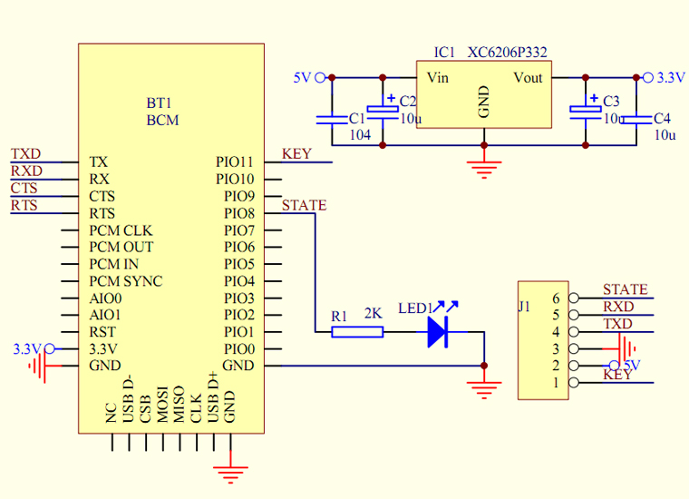

Figure 7.5

We use the HC-05 Bluetooth module. Figure 7.5 shows the schematic of the HC-05 Bluetooth module. The Bluetooth module serves as a communication method between the Main Hub Arduino and the Android App on the Android phone.

### 6.5.2 *Bluetooth* interface description

The Bluetooth module has six pins. We only need to use four out of the six pins on the Bluetooth module. One pin for 5V, one for GND, one for RX, and another for TX.

### *6.5.3 Bluetooth* processing details

* 2.4 GHz radio transceiver
* 3.3 - 5V input power
* Supported baud rate: 9600,19200,38400,57600,115200,230400,460800

## MCP2515

### 6.6.1 Processing narrative for *MCP2515*

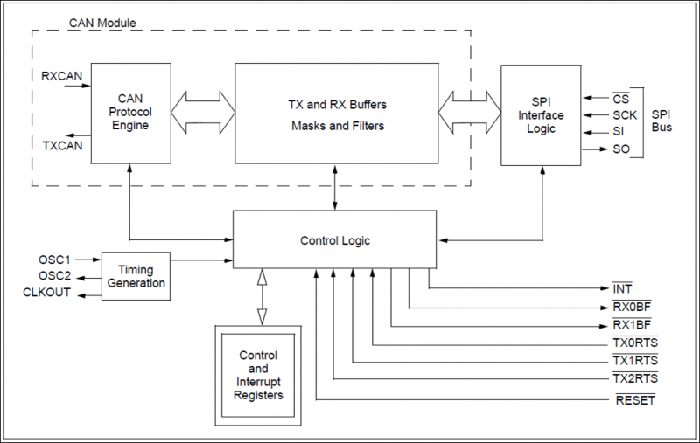

Figure 7.6

The MCP2515 is the CAN Controller for the CAN_PCB. Figure 7.6 is the block diagram of the MCP2515. The MCP2515 serves a key part to the CAN_PCB to send data from the Arduino to the MCP2551.

### 6.6.2 *MCP2515* interface description

The MCP2515 has eighteen pins and two are for power and GND. Four pins are for the SPI communication between the MCP2515 and the Arduino Uno. Two pins serve as the clk input and output, and two pins serve as the communication between the MCP2515 and the MCP2551. One pin serves as the interrupt when a message comes through and the reset pin uses a 1k ohm resistor.

### *6.6.3 Bluetooth* processing details

* Operates from 2.7V – 5.5V
* Implements CAN V2.0B at 1 Mb/s
* High-speed SPI Interface (10 MHz)
* 5 mA active current (typical)

## MCP2551

### 6.6.1 Processing narrative for *MCP2551*

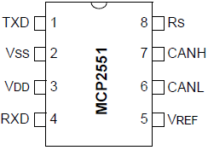

Figure 7.7

The MCP2551 is the transceiver in the CAN_PCB. Figure 7.7 shows the pinout of the MCP2551. The MCP2551 serves as the final transmission between the MCP2515 and the CAN Bus. It reads and sends data to and from the CAN Bus.

### 6.7.2 *MCP2515* interface description

The MCP2551 has eight pins, which two include the power and GND. One pin is CANH and another pin is CANL. Two other pins serve as communication between the MCP2551 and the MCP2515. Also Rs has a 4.7k Ohm resistor connecting into GND.

### *6.7.3 MCP2515* processing details

* 1 Mb/s operation
* 3.3V to 5V power operation

# * Technical Problem Solving

***Document all the technical difficulties you encountered***

## Pull Up Resistor Missing

Problem: When we started to connect the CAN controller and transceiver together, we mistakenly put a wire to 5V instead of a resistor, this kept causing CAN initialization failure every single time.

Steps taken to solve problem:

1. Verified our schematic with multiple schematics.
2. Located and verified necessary resistor for the pin.

Problem Solution: Replaced the wire with a pull up resistor and tested CAN communication once again. We were able to finally achieve CAN initialization. Without the resistor we kept running into our communication failing or crashing. The wire and pin located on the reset pin were both constantly picking up any signals and noise around us and would cause the communication to fail. This problem caused us a delay in our project for about 2 weeks where we were constantly checking the wrong schematic and forgetting about our reset pin.

## The Space and Weight Problem

***Describe the problem, who contributed to the identification of the problem***

Problem: When we test the movement of the vehicle through CAN communication, the amount of space the CAN communication circuit takes up is too much.

Steps taken to solve problem:

1. Verify our CAN communication circuit works
2. Learn PCB design
3. Make PCB of the CAN communication circuit

Problem Solution: To fix the solution we downloaded Eagle Cad, a software for designing PCBs. We then spent a few days learning how to do PCB design and making the PCB. Once we finalized our design we sent the design to Pavle to be printed by a PCB mill. Once Pavle printed the CAN_PCB for us, we tested the same code with the CAN_PCB instead of the previous CAN communication circuit we had set up on our breadboards. The vehicle was able to drive just as before with the CAN communication circuit. Creating the CAN_PCB saves massive amounts of space on the vehicle and reduces the total weight of the vehicle as well.

# User Interface Design

This section provides user interface design descriptions that directly support construction of user interface screens.

State clearly who is responsible for which module/task

## *Application Control

Detail the common behavior that all screens will have. Common look and feel details such as menus, popup menus, toolbars, status bar, title bars, drag and drop mouse behavior should be described here. Conventions and standards used for designing/implementing the user interface are stated.

## User Interface Screens

Illustrate all major user interface screens and describe the behavior and state changes that the user will experience. All screen objects and actions are identified.

A screen transition diagram or table can optionally be created to illustrate the flow of control through the various screens.

This does not have to be actual screenshots since they have not been programmed. They can be powerpoint drawings or mockups created in Visual Basic or some other rapid GUI-building tool.

# * Test Plan

## * Test Design

***Design tests to verify whether your design meets the design objectives and test your modules and the prototype you built. The set of tests which constitute your test plan are to be specified, including as much detail as is possible at this stage.***

**Tests and expected responses**

***Specify the tests and the expected results.***

***Test Case i (repeat for i=1,…n):***

1. ***What is the objective of the experiment? What function does it test? Which technical design objective does this measure?***
2. ***Experiment setup***
3. ***Experiment procedure and how to collect data***
4. ***Expected results***

***State clearly who is responsible for which experiment***

Test Case #1 - CAN Initialization (Hernan)

1. Objective: The objective of this test is to initialize CAN so that we can implement the CAN protocol on our vehicle and then create our PCB design which will be added to the vehicle to and wired to the ECUs.
2. Setup: Wire up both CAN Bus Shields and attach to bus line.
3. Procedure: After wiring up the CAN H and CAN L from the shields to the bus, upload the modified code from the library so that both ECUs can receive and send messages.
4. Results: Both ECU’s successfully initialized after changing to the correct baud rate.

Test Case #2 - Locking and Unlocking Mechanism (Hernan)

1. Objective: Have the stepper motor move 45 degrees clockwise and counterclockwise at command.
2. Setup: Connect Stepper Motor 28BYJ-48 to ULN2003AN Driver and connect to Arduino.
3. Procedure: Upload code to Arduino and bring up serial monitor to implement, lock and unlock.
4. Results: Was able to shift 45 degrees counterclockwise and clockwise.

Test Case #3 - L298 Motor Driver Setup (Hernan)

1. Objective: Integrate motor driver on vehicle and wire to DC motors.
2. Setup: Attach power supply, DC motors, and Arduino to Motor Driver.
3. Procedure: Upload code to driver, attach bluetooth module, send corresponding data over.
4. Results: Able to make the car move forward, reverse, left, and right.

Test Case #4 - GPS Coordinates over CAN (Chirag)

1. Objective: Confirm GPS coordinates are sent and received over the CAN bus to ensure proper translation of GPS data to CAN message format and the reverse translation.
2. Setup: GPS connected to Arduino passed “GPS Accurate Signal Test”. Code converts long format coordinates to byte array. Arduino is connected to CAN bus, which is also connected to a CAN bus reader/receiver Arduino. Receiver Arduino has code to convert byte array from CAN back to long displayable format.
3. Procedure: Go outside, start Arduinos. Record serial monitor logs of receiver Arduino.
4. Expected Results: CAN bus has messages with ID of latitude/longitude being sent. Serial monitor shows messages on the CAN bus (pre-translation) and latitude/longitude coordinates obtained from the bus (post-translation).

Test Case #5- Headlights ECU Headlights State Machine Test (Chirag)

1. Objective: Ensure functionality of Headlights state machine.
2. Setup: CANHub ECU and Headlights ECU are connected to CAN bus. Arduino app is connected to CANHub via Bluetooth.
3. Procedure: Tap “Headlights” toggle on Android app. Tap the “Headlights” toggle again.
4. Expected Results: Android app sends “Headlights ON” signal via Bluetooth to CANHub. CANHub translates “Headlights ON” signal to CAN message with ID 0x310. CAN message is received by Headlights ECU. Headlights LED’s turn ON. When toggle is pressed again, the same procedure is followed but the headlights LED’s turn OFF.

Test Case #6 - Bluetooth Send(Todd)

1. Objective: Have the app send data via button presses.
2. Setup: Program and connect Arduino to the Bluetooth module. And program the app to send data over Bluetooth
3. Procedure: Upload code to phone and Arduino, then press buttons to see if data was sent.
4. Expected Results: Arduin receives and displays the data from the app.

Test Case #7 - Bluetooth Receive(Todd)

1. Objective: Have the app receive data via the Arduino.
2. Setup: Program and connect Arduino to the Bluetooth module. And program the app to receive data over Bluetooth
3. Procedure: Upload code to phone and Arduino, then send data over the serial monitor to see if the app displays it.
4. Expected Results: The app correctly displays the data sent over Bluetooth from the Arduino.

Test Case #8 - Display GPS Coordinates(Todd)

1. Objective: Display on Android app GPS coordinates received via Bluetooth from CANHub ECU
2. Setup: Program the main hub Arduino to look for the GPS data over the CAN bus. Then send the data to the app via Bluetooth.
3. Procedure: Go outside, start Arduino and app. Then monitor the serial monitor of the main hub Arduino and the text label of the app.
4. Expected Results: The app properly displays the longitude and latitude coordinates the GPS ECU sends over the CAN bus.

Test Case #9 - Motor Controls with CAN(Todd)

` 1. Objective: Test the data sent over the CAN Bus to the motor driver Arduino

2.Setup: Program the motor driver Arduino to receive data from the CAN Bus and output correct data

3.Procedure: Setup the motor driver Arduino and the main hub Arduino to the CAN Bus

4.Expected Results: The motor driver outputs the correct signals when the data is sent from the CAN Bus

Test Case #10 - GPS Coordinates without CAN

1. Objective: Test if the module is functioning and learn the NMEA protocol.
2. Setup: Set up the GPS module, upload the tinygps library, and go outside to receive the location.
3. Procedure: Wait outside to receive the location taking up to 10 minutes depending on location.
4. Results: Able to receive the location after 5 minutes of waiting outside.

## * Bug Tracking

***A database will be used to track defects found while performing the test cases. All defects will be logged as they are discovered. Defects will be assigned to Person A to fix, or to Person B to investigate.***

As bugs appears we write it in our notebooks. And whenever we find bugs we message our group about the bug to report it. If any of us need help we ask the others for it, otherwise the person who is responsible for the module or code where the bug originates from is to investigate and fix it. If the bug is affects a critical component then the person tasked with the component has a deadline to fix it.

## * Quality Control

***The completed test cases will be reviewed to ensure that all cases were run; that all were completed successfully; and that any deviations from the test cases were noted accordingly. Each step should be marked as Passed or Failed. Failed cases should be marked with the date and time of the failure, and the associated test track number. When a failed case is fixed, the date and time of the retest should be noted***

Test Case #1

1. Date test took place: 8/21/16
2. Test Report: Test Case #1
3. Pass or fail: Pass

Test Case #2

1. Date test took place: 2/3/17
2. Test Report: Test Case #2
3. Pass or fail: Pass

Test Case #3

1. Date test took place: 12/14/16
2. Test Report: Test Case #3
3. Pass or fail: Pass

Test Case #4

1. Date test took place: 1/23/17
2. Test Report: Test Case #4
3. Pass or fail: Pass

Test Case #5

1. Date test took place: 1/27/17
2. Test Report: Test Case #5
3. Pass or fail: Pass

Test Case #6

1. Date test took place: 1/28/16
2. Test Report: Test Case #6
3. Pass or fail: Pass

Test Case #7

1. Date test took place: 2/5/17
2. Test Report: Test Case #7
3. Pass or fail: Pass

Test Case #8

1. Date test took place: 2/17/17
2. Test Report: Test Case #8
3. Pass or fail: Pass

Test Case #9

1. Date test took place: 1/12/17
2. Test Report: Test Case #9
3. Pass or fail: Pass

Test Case #10

1. Date test took place: 1/16/17
2. Test Report: Test Case #10
3. Pass or fail: Pass

## * Identification of critical components

***Describe the components that are critical and demand particular attention during testing are identified.***

LiPo Battery: The LiPo Battery is a critical component because if not handled correctly, it will result in an explosion or fire. When we are testing, we make sure the LiPo battery leads are nowhere near each other. Also, make sure the LiPo battery is secure when we are testing. If the LiPo is not properly discharging can also cause an issue. We can fry components if the LiPo is not properly discharging.

GPS Module: The GPS Module is a critical component requiring testing because it is our most complex sensor. It must communicate with Android via UART, obtain a signal, and obtain accurate location data. This sensor is sensitive to environmental conditions such as weather and therefore requires special attention and care when handling.

## * Items Not Tested by the Experiments

***List any functions or processes not being tested by the experiments and why.***

RC Car Motors: We chose not to test the actual motors on the RC Car that we purchased since the motors functioned properly before we removed the RC components.

# * Test Report

***Carry out the experiments designed in the section above to test your modules and prototype and present the results. Present the results of the experiments and provide an analysis of the experimental test data.***

***State clearly who is responsible for which test case***

***Each test must be run multiple times. When you find deviation from the expected results, you must take action to debug your design, then test it again. Report each test iteration below***

we need to fix the section headings so that they appear on the table of contents.

## Test 1 - CAN Initialization (Hernan)

***Person(s) performing the experiment***

1. ***Test results, person performing the test***
2. ***Comparison with expected results***
3. ***Analysis of Test results***
4. ***Corrective actions taken***

***Must be performed multiple times. Report the above for each iteration of the test.***

1. Test Result



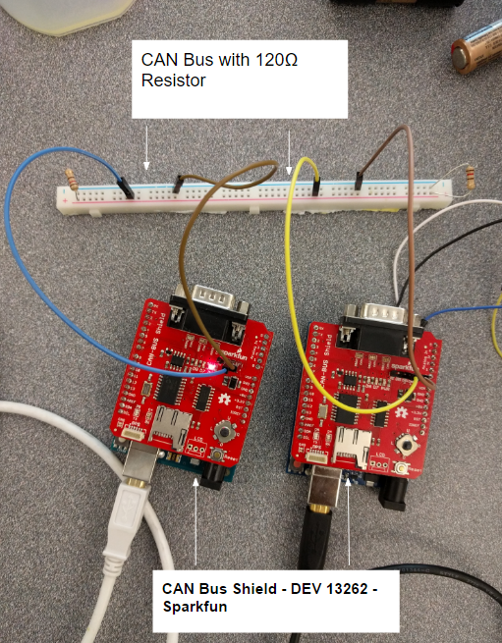

2. Comparison with expected results: I was able to achieve the expected results.

3. Analysis of Test Results:

PASS. The setup with the shield was much easier than implementing our own PCB design to replicate the communication. For the shield the only trouble we had when running into a failure in initialization was due to choosing an incorrect baud rate on the serial monitor. After choosing the correct the baud rate and sending over the data in the proper CAN protocol it never failed.

4. Corrective actions taken: None, I proceeded to follow the necessary steps and had no problem.

**10.2 Test 2 - Locking and Unlocking Mechanism (Hernan)**

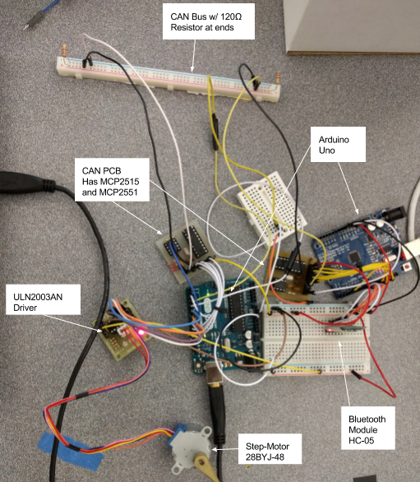

1. Test Results: I was able to make the Step Motor move 45 degrees clockwise and counterclockwise.
2. Comparison with expected results: PASS. After having the stepper motor move 45 degrees clockwise and counterclockwise, I proceed to try to move it 90 degrees and it would glitch and move 180 degrees. The only thing changed was the amount of steps to move 90 degrees, which was double the steps of 45 degrees. Yet it would not glitch for the 45 degrees it would always move to the correct position. This was then implemented with CAN and was able to get it to move with the mobile with a toggle button with the assistance of Todd.
3. Analysis of Test Results:
4. Corrective Actions Taken:

**10.3 Test 3 - L298 Motor Driver Setup (Hernan)**

1. Test Results:



2. Comparison with expected results: I was able to attain the expected resulted that was discussed the previous sections.

3. Analysis of Test Results:

PASS. Having setup the motor driver before for another project, I was able to recreate the same process for the motors on the vehicle. The results were exactly what I was expecting and had no trouble setting this part up except for when adding CAN, and this was easily fixed with the assistance of Todd and creating the buttons on the mobile app.

4. Corrective Actions Taken: There was no necessary actions taken, all worked out fine by following the proper actions.

**10.4 Test 4 - GPS Coordinates over CAN (Chirag)**

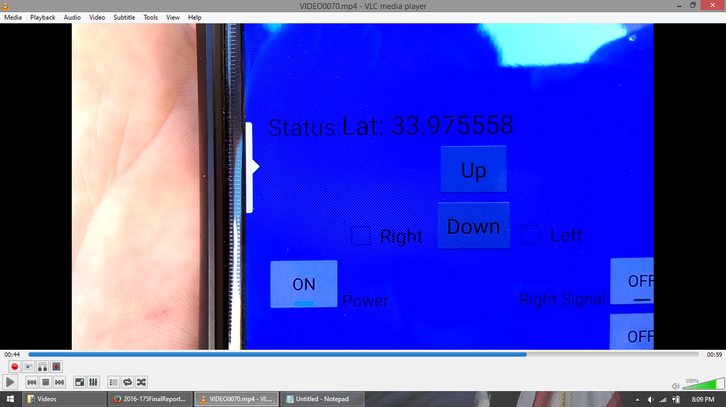

1. Test Results: PASS
2. Comparison with Expected Results: I was successfully able to send GPS coordinates over the CAN bus as expected.
3. Analysis of Test Results: The test demonstrated proper CAN message communication by having the correct ID’s for latitude and longitude. It also demonstrated the GPS ECU’s successful conversion of the long data type GPS coordinates to CAN message byte array. The test ensured that a receiver could also translate in the reverse, from CAN message byte array to long.
4. Corrective Actions Taken: No corrective actions were necessary.

**10.5 Test 5 - Headlights ECU Headlights State Machine Test (Chirag)**

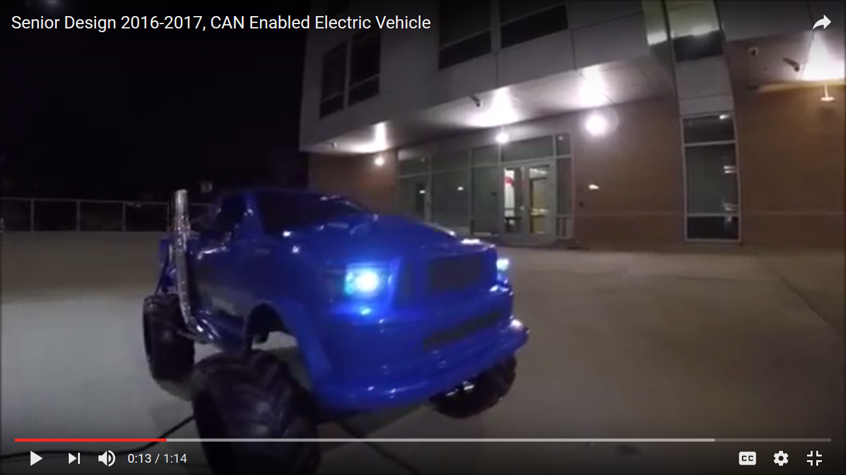

1. Test Results: PASS
2. Comparison with Expected Results: As expected, the headlights LED’s turned ON when the Android app toggle was switched to ON and the headlights LED’s turned OFF when the Android app toggle was switched to OFF.
3. Analysis of Test Results: In addition to validating the Headlights State Machine, this test demonstrates that two layers of communication, namely Bluetooth and CAN, function as expected. The CANBus ECU receives signals from the Android app via Bluetooth. The Headlights ECU receives signals from the CANHub ECU via CAN bus. Upon receiving a signal with CAN ID 0x310, the Headlights ECU enables the headlights state machine, confirming that we are able to control simple car functions using an Android app.
4. Corrective Actions Taken: No corrective actions were necessary.

**10.6 Test 6 - Bluetooth Send**

1. Test Results:The test passed, and Todd performed this test
2. Comparison with expected results: Figure 4.3 is the expected result of the app sending data to the main hub Arduino.

3. Analysis of Test Results: The app was able to send data to the main hub Arduino. It works with all the buttons on the app. When I press any button the corresponding data appears on the main hub’s serial monitor.

4. Corrective Action: No corrective actions were needed.

**10.7 Test 7 - Bluetooth Receive**

1. Test Results: The test passes, and Todd performs the test.
2. Comparison with Expected Results: The test results were the same as the test results. The app correctly displays the data sent from the main hub Arduino.
3. Analysis of Test Results: When I press a button on the app, the same data gets sent back from the main hub Arduino. The main hub Arduino has a feedback function, when the app sends the data the main hub reads it and sends it right back.
4. Corrective Action: No corrective action was needed.

**10.8 Test 8 - GPS Display**

1. Test Results: Pass and Todd is the tester.
2. 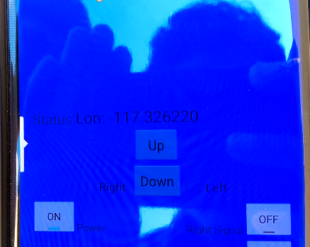

Figure 10.7

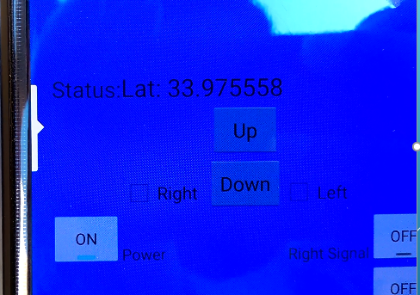

Figure 10.7.2

Comparison with Expected Results: Figure 10.7 and 10.7.2 show the app receiving the longitude and latitude from the GPS unit. This is what I expect from the test.

3. Analysis of Test Results: Having setup the GPS Arduino and the main hub Arduino to the CAN Bus, I am able to get the main hub Arduino to send the data to the app. The GPS Arduino finds the geolocation and sends the data through the CAN Bus to the main hub Arduino. Then the main hub Arduino reads the data and sends it to the app.

4. Corrective Action: No corrective action was taken.

**10.9 Test 9 - Motor Driver Controls with CAN**

1. Test Results: The test passes and the tester is Todd
2. Comparison with Expected Results: The actual results did meet with the expected results. The motors move when I send data over the CAN Bus.
3. Analysis of Test: After setting up the motor driver Arduino and the main hub Arduino, the results are correct. The motors move with data being sent over the CAN Bus. The wheels were able to move forward, reverse, left, and right. They were also able to move both motors at the same time.
4. Corrective Action: No corrective actions were needed.

**10.10 Test 10 - GPS Testing without CAN -Hernan**

1. Test Results: I was able to receive the location over the GPS.
2. Comparison with expected results: I got what I needed from the expected results.
3. Analysis of Test Results: For the GPS module to work it took some time modifying the code and waiting for the satellites to connect and then receive a location, it took me about 7 minutes to receive the location.
4. Corrective Actions Taken: No actions were required.

## * Test i (one section for each test i = 2, …., n)

***Person(s) performing the experiment***

1. ***Test results, person performing the test***
2. ***Comparison with expected results***
3. ***Analysis of Test results***
4. ***Corrective actions taken***

***Must be performed multiple times. Report the above for each iteration of the test.***

# * Conclusion and Future Work

## * Conclusion

***Present the conclusion of your project, state clearly whether the finished work meet the overall project goals and the quantitative technical design objectives. If not, just state what and how it failed and the TECHNICAL reasons why it failed and what you have learned.***

***State clearly who is responsible for achieving or missing which goals/objectives.***

***\* Must complete for each team member: Describe what you learned from this project, both in terms of technical knowledge and skill, professional and personal growth.***

***Do NOT complain and give personal, non-technical reasons why it failed. You should talk to your advisors about these, but do not include them in a design document.***

**Hernan Diaz:**

After completing this project, we have successfully implemented the industry protocol of CAN communication. Even after two ECU’s we were able to each one receive and send messages via the bus and have confirmation of the messaging on our mobile app. We were all able to work together without a problem and actually helped each other by focusing on each strongest subjects and applying that knowledge unto our project. It allowed for efficient communication and building a good relationship. We would test each other’s modules, share ideas, and solve each other solutions when each of us struggled. Not only did we learn from the project itself, we learned from each other.

**Chirag Dixit:**

Our initial project idea was to simply interface into a real car’s OBD port and send CAN messages over Bluetooth from an Android app to toggle various functions of the car. This project was much more. We implemented our own network, created our own CAN message formats, designed and built our own ECU’s, and wrote our own Android app. We exceeded our expectations for this project. We first learned how to research. We learned more about CAN and communication as a whole than we anticipated. Then we built it. We collaborated on most functions of the project, communicating throughout the process, and learning many new skills along the way. My big lesson learned was to follow the Agile methodology properly. Although we had individual components and ECU’s completely function, combining them into the whole system proved to be a time consuming challenge. Ultimately, our hard work and dedication paid off with a functional project. From my contributions to the project, I learned several new technical skills like Arduino, CAN communication, and Bluetooth. From my team members, I learned how to collaborate with a team, communicate effectively, and motivate my peers. This project pushed us to learn more and do more, and together, we created our own CAN Enabled Electric Vehicle.

**Todd Larson:**

We were able to implement the industry standard of the CAN system. We were able to get all the ECUs to communicate with each other over the CAN bus. However, we did not get all the ECUs on the RC car at once. We just did not have enough time to run more tests and integrate all the ECUs on the RC car. In the end we all learned how to implement and design our own CAN communication system. Not only was CAN communication set up, but communication between all of us was essential. We met most of our goals and we were able to help build off of each other's work.

## Future Work

Expansion and Improvement; discuss the impact of this work and its possible expansion into perhaps a more promising design than what you had started. This is particularly important in order to address the marketability of your design. Or why this project merits another look by perhaps next year's students.

Currently the distance our vehicle can travel is 30 feet due to our bluetooth module. A better approach to increasing the distance of our vehicle would be to switch to radio frequency instead of bluetooth communication, increasing our vehicle distance significantly.

In our modern times, one key problem we face is security protection. The hacking into modern cars is becoming easier if the vehicle software is not updated or properly secured. In our project, although much simpler, the fact that we use bluetooth makes it much simpler to control our vehicle if someone connects to the same bluetooth module. The best way to avoid this would be to use an actual key that would turn on the car, instead of turning it on remotely.

In addition, to increase the amount of space in our vehicle, the best approach would be to get rid of the Arduino, the CAN Controller, and CAN Transceiver, by replacing the parts with a Teensy. The newer Teensys are a third of the size of an arduino with twice as many pins that an Arduino has, and is CAN Enabled.

## * Acknowledgement

***Be considerate and credit all those who have helped you in this project, especially credit the people who provided ideas or solutions.***

**Roman Chomko:**

For guiding us in our design and changing our lives one day at a time at a critical moment in our lives.

**Pavle Kirilov:**

For 3D printing our latch , soldering our CAN controllers, and printing our PCB design.

**Jose Alejandro Aguilar:**

A Graduate student who assisted in our troubleshooting with our circuit analysis for our solenoid and troubleshooting our other components.

**Peter “Donut Boy” Hung**

For motivating us everyday with his positive attitude and a promise of free donuts. His technical knowledge of Arduino and pastries proved invaluable to the project.

# * References

***List the references used in the design, including books, data sheets, technical documents, industry standard documents. References can be printed documents or online.***

***Use the IEEE Citation procedures and list in alphabetic order all your references based on their first, second, etc., authors, in a chronological order. You may include these references depending on each chapter or as a whole.***

The references used in the design are listed below, including data sheets, books, technical documents. References can be looked through or discussed online.

* https://www.kvaser.com/about-can/the-can-protocol/
* https://github.com/coryjfowler/MCP_CAN_lib
* <https://www.canb.us/tutorials/Tapping%20into%20a%20bus>
* <http://hackaday.com/2013/11/05/can-hacking-the-hardware/>
* <https://www.cooking-hacks.com/documentation/tutorials/can-bus-module-shield-tutorial-for-arduino-raspberry-pi-intel-galileo/>
* <https://www.can-cia.org/can-knowledge/>
* <http://isil-electro.wikispaces.com/CAN>
* https://www.sparkfun.com/datasheets/DevTools/Arduino/MCP2515.pdf
* <http://www.instructables.com/id/How-to-Communicate-Neo-6M-GPS-to-Arduino/?ALLSTEPS>
* <http://modelrail.otenko.com/arduino/arduino-controller-area-network-can>
* <http://ww1.microchip.com/downloads/en/AppNotes/00228a.pdf>
* <http://www.computer-solutions.co.uk/info/Embedded_tutorials/can_tutorial.htm>
* https://learn.sparkfun.com/tutorials/serial-communication
* Voss, Wilfried. Controller Area Network Prototyping with Arduino. Greenfield: Copperhill Technologies Corporation, 2014. Print
* <https://www.google.com/url?sa=i&rct=j&q=&esrc=s&source=images&cd=&ved=0ahUKEwjPnJqszc3SAhUY84MKHXshBQIQjBwIBA&url=http%3A%2F%2Fforum.arduino.cc%2Findex.php%3Faction%3Ddlattach%3Btopic%3D146315.0%3Battach%3D90365&bvm=bv.149397726,d.amc&psig=AFQjCNGmIVxefrs9CJe4dWEYl_OQcj_XQA&ust=1489292575927014&cad=rjt>
* <https://hobbyking.com/media/file/512530569X967X52.jpg>
* <http://www.electroschematics.com/wp-content/uploads/2014/11/arduino-uno-r3-schematic.png>
* <http://fritzing.org/media/fritzing-repo/projects/w/working-with-l298n-dc-motor-driver/images/L298_motor.jpg>
* <http://www.elecfreaks.com/wiki/images/5/54/Wireless_BTH_05-LRG.jpg>
* Chomko, Roman. "GPP Program - BT Data Comm". Dropbox. N.p., 2017. Web. 10 Feb. 2017.

# * Appendices

Presents information that supplements the design specification, including:

***\* Appendix A: Parts List***

* MCP2515-I/P-ND IC CAN Controller W/SPI 18DIP
* MCP2551-I/P-ND IC Transceiver CAN HI-SPD 8-DIP
* Adafruit Neo-6M GPS
* Arduino Uno
* DROK L298N Motor Drive Controller Board
* Stepper Motor, 28-BYJ48 with ULN2003AN driver
* Small Push-Push Solenoid
* CAN Bus Shield DEV 13262 (For testing initialization)
* RC Car
* Crystal 16.000MHz 20pF T/H
* 2200mAh 3S 20C Lipo Pack
* LED’s

***\* Appendix B: Equipment List***

* USB Cable for Arduino Uno
* Multimeter
* Power Supply(For testing purposes)
* Oscilloscope(Verifying CAN communication on the bus)
* Laptop

***\* Appendix C: Software List (URL to online drive or SVN server, with sharing set to Public. Can omit this appendix if your project didn’t involving writing a program)***

* *Android Studio: Program for mobile phone app*
* *Arduino IDE: Program microcontroller*

***Appendix D: Special Resources***

* ***N/A***

***Appendix E: User's Manual - If your design requires instructions for future use, here is the place to put that information.***

***Appendix F to Z: Whatever Else You Wish To Add; for instance, here, you may include detailed solution methods or derivations, which you need for your future review of this report or whoever else is interested to pursue this study. Some side drawings and printouts that are of value to people who will continue this work should be given herein. Some information about the vendors and how to locate parts for similar projects must be included herein. In other words, information that is important about the overall construction of the project should be given herein.)***